Overview
- This document is intended to describe an approach to converting Xcalibur RAW datafiles (*.RAW) to Agilent ChemStation format datailes (*.D), for the purpose of processing, reviewing and/or reporting analyses, acquired on an Xcalibur-based MS instrument, in ChemStation.
- The process of converting *.RAW fles to *.D files cannot be done in a single step. There is no Thermo-provided or third-party-available software package to do this. This document describes a two-step process, involving the use of a post-acquisition program plus a third party tool, the Vx Capture software (available through Adron Systems). Although this is a two-step process, the entire dataflow can be completed fully automatically, with no need for user interaction.
- The first step is the conversion of the *.RAW file to a text file format (*.ASC); by default, the *.ASC file is created in the same folder as the *.RAW file. This file contains various sample header elements (i.e. sample name) along with each mass spectral data point.
- The second step is the conversion of the *.ASC file to the *.D format; by default, the *.D file is created in the same folder as the *.ASC file. This file contains the ChemStation-available sample header elements along with the complete mass spectral dataset.
- The total file conversion process can be done fully automatically through the use of Xcalibur’s processing queue along with the ‘file watch’ capabilities of Vx Capture. The file conversion process can also be done as an Xcalibur batch reprocessing activity; alternatively, the file conversion can be done as two distinct and manual operations.
Requirements / Components
- XcaliburToTextV7b.exe – this is the executable which converts the *.RAW file to the *.ASC file format.
- Adron System Vx Capture, version 3.22.138 (or later) – this is the program which converts the *.ASC file to the *.D format.
Installation / Configuration
Adron Systems Vx Capture
- Install the Vx Capture software, following the documentation provided by Adron Systems. As necessary, be sure that the license dongle is attached to a functioning USB port on the PC.
Xcalibur
- Copy the file XcaliburToTextV7b.exe to c:\xcalibur\system\programs
- Optionally, create a shortcut on the desktop to the XcaliburToTextV7b.exe program
- Create an Xcalibur processing method, and access the Programs view
- Within the Programs view
  - Click the Enable checkbox to create a programs row
  - Double-click in the Programs and Macro Name field, and browse to the XcaliburToTextV7b.exe file; select it to place it into the programs row
  - Add the text %R to the Parameters field
- Click the OK button to accept these changes, and then save the Xcalibur processing method
Setup / Operation
Adron Systems Vx Capture
- Launch the Vx Capture software from the desktop or Windows Start menu.
- On the Instrument menu, select Instrument #1 and Properties from the sub-menu.
- In the Properties dialog, per the figure below
  - Change the Instrument Name to XcaliburToChemStation
  - Set the Source Type to Adron Systems Text File
  - Set the Target Type to Agilent ChemStation
  - Click OK when finished
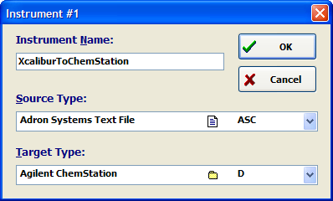
- On the Instrument menu, select XcaliburToChemStation and Select from the sub-menu, to make this the default and active file converter
- On the Job menu, select Create Job…
- In the Create Job dialog, per the figure below
  - At the bottom of the dialog, select the tab marked Wildcard Search for Source Files
  - Click the folder icon and delete any text in the Target Directory text box (this will place the final *.D file in the same folder as the original *.RAW file)
  - Check the box for Delete Original File (this will delete the *.ASC intermediate file, to save disk space; it will not delete the *.RAW file)
  - Due to the limits on the maximum intensity of some versions of ChemStation, it may be necessary to scale the *.RAW data in order to fit it into the available intensity space for a ChemStation file. If this is necessary, check the box for Scale Target Abundances by: and enter a value to be multiplied by each m/z value’s intensity. It may be necessary to determine this empirically, based on highest quantification standard or expected maximum sample concentration.
  - In the Search Criteria Name text box, enter *.ASC as the source file type.
  - In the Search Criteria Directory text box, enter (or, preferably, use the file folder icon to browse in) the folder where the .RAW datafiles were originally acquired (which will also be the location of the generated *.ASC files)
  - The Search Criteria entries allow the Vx Capture software to continuously monitor a location for certain file types. This monitoring can be left on for an extended period of time using the From and To date and time fields. IMPORTANT – the monitoring and conversion will not be performed, even if Vx Capture is left running, if the date/time stamp for an ASC file is outside the range specified by the From and To fields.
  - Click OK when finished.
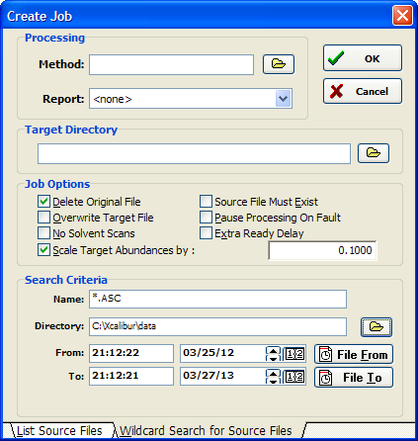
- To begin monitoring for file conversion, click the Play/Resume button on the toolbar (alternatively, you can select Resume | Instrument from the Capture menu). The application’s status bar message will display Searching… and then Waiting for available file when it is in monitoring mode, and ready for use.
Xcalibur
- Within Xcalibur’s Sequence View, confirm that a column is available for the processing method (labeled Proc Meth); if this column is not available, it can be added using the Change|Column Arrangment… menu selection.
- When creating a sequence, ensure that the sequence is of the type “No Bracket” or “None” if the files are to be converted following the completion of each acquisition. All other bracket types will not begin processing until the final sample in the sequence is finished, or until the sequence is cancelled or otherwise stopped. One way to help ensure this is to use the New button on the toolbar, bringing up the New Sequence Template dialog, which includes an option to select the bracket type.
- The folder to be used for *RAW file creation/storage (labeled Path) should be the same as the one selected as the Search Criteria Directory in Vx Capture.
- Once a sample is entered into an available row in the sequence table, double-click in the Proc Meth field for the row (the Browse menu can also be accessed through the right mouse click context menu for that field). Browse to the processing method, created above, which includes the XcaliburToTextV7b executable.
- When the sequence is ready to be submitted for acquisition, use either the Run Sample or Run Sequence commands (tool bar buttons or menu choices under Action) to bring up the submission dialog.
- Click the Programs checkbox in the Processing Actions frame to allow the file conversion program to be run following the acquisition; if the Programs checkbox is not selected, the file will not be converted.
Possible Issues / Bugs
- If the sample injection’s Xcalibur RAW datafile is open in Qual Browser when the acquisition is finished and the XcaliburToTextVtb program is activated, the RAW file may not be available for processing by the file conversion system. An error dialog may be presented and the injection’s rawfile will not be converted.

